1. Who I received the file from
2. What’s the name of the file.xlsx
3. How often I get the file
4. Where its located

Types of cleaning

1. I move columns
2. I delete column x

Then I add calcs

In column F ( I create it before I start), I then paste =CONCATENATE(D2," ",E2)

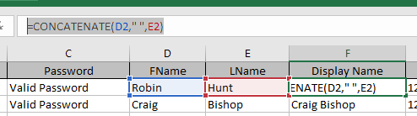

I then add conversion functions in columns E F and G

